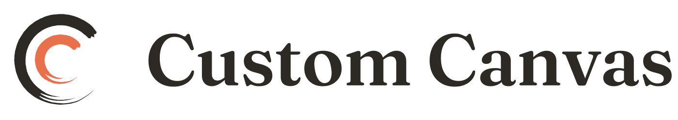
CUSTOM CANVAS
Seller Protection Policy

STATUS | DRAFT. Part of the Artist Agreement. The system is live; this document is not.
AUDIENCE | Artists
VERSION | Draft v1.0
PREPARED | 25 August 2026
ENTITY | Custom Canvas LLC, a Texas limited liability company
Prepared for review by counsel. Not legal advice, and not prepared by a lawyer.
DRAFT — complete draft for counsel review. The system described here is live in production as of 2026-08-25; this is the artist-facing document for it, which does not yet exist.

This policy is part of the Artist Agreement, incorporated into §4 by reference and versioned with it. It is kept as a separate document because it decides who bears a chargeback, which is the single term most worth reading properly, and because it is the term most likely to change as the platform's evidence handling improves.

The principle
Protection is a bargain, not a benefit. You bear a chargeback by default. Custom Canvas covers it instead when you did the things that would have won the dispute.
Every dispute — won or lost — counts against Custom Canvas's standing with the card networks, not yours. One careless sale can jeopardise processing for every artist on the platform. That is why the requirements are what they are.

When Custom Canvas covers a chargeback
An order is Protected when all of the following are true:
- Shipped within 5 business days of the sale
- A tracking number from USPS, UPS, FedEx or DHL recorded before you marked it shipped
- Delivery confirmed to the address on the Custom Canvas order and recorded before the dispute arrived
- Signature confirmation obtained, for orders of $750 or more
- Your listing carried 3+ photographs and a description of 150+ characters — as measured at the time of sale
- No buyer message about the order left unanswered for more than 3 business days, between the sale and confirmed delivery and for any later message about that order

Two limits to know about before you rely on this:
Delivery confirmation is your attestation, not the carrier's. We do not yet read tracking from carrier APIs, so marking an order delivered is something you record. It still has to be true. A false attestation is a breach of the Artist Agreement and forfeits protection. Carrier verification is coming, and we will tell you before it changes.
Local pickup is not eligible today. The rule is that pickup is Protected when both parties confirm handoff in the message thread, but that confirmation feature is not built yet, so pickup orders currently evaluate as unprotected. Until it ships, treat a pickup sale as carrying its own risk, and still get the buyer to confirm the handoff in writing in the thread. It remains the best evidence available to you.

Why each requirement exists
They are not arbitrary — each is a piece of evidence a card network actually weighs:
- Tracking and delivery are the single strongest defence against "I never received it", which is the most common dispute.
- Signature at $750 matches the card networks' own evidence rules for higher-value goods.
- Photographs and a real description are what defeats "not as described". A listing that says only "Beautiful abstract in blues, ready to hang" defends nothing — which is exactly why the bar is 150 characters rather than a token minimum.
- Answering messages resolves most complaints before a bank is ever involved.

Requirement 5 is frozen at the moment of sale
Photograph count and description length are recorded when the buyer pays and cannot be changed afterwards. Adding photographs to a sold listing does not retroactively protect that order — it protects the next one.

Seeing where you stand
Every order in Studio → Sales shows its protection standing before any dispute exists, and expands to list precisely what is missing. Anything still fixable is listed separately from anything already fixed at the point of sale.

Conceding is free
If a dispute arrives and you would rather accept it than fight it, you pay no penalty and your record stays clean. Fighting a dispute you will lose costs everyone.

What happens when a dispute arrives
- We mark the order disputed and tell you immediately, stating in the first line whether you are protected.
- We ask for any shipping or delivery evidence you hold, and we respond to the bank.
- If we win, nothing changes and your payout stands.
- If we lose and the order was Protected, Custom Canvas absorbs the loss and your payout is not touched.
- If we lose and the order was not Protected, the payout is reversed.

A reversal can push your Stripe balance negative. That is why payouts run on a 14-day delay — so the money is usually still in your Stripe balance rather than already spent out of your bank account.
If your balance will not cover a reversal, the shortfall is a debt to Custom Canvas and we recover it by setting it off against your future payouts. We will tell you the amount and how it is being recovered. We may also hold a payout or place a reserve while we investigate a dispute or a claim about a piece, for no longer than the investigation reasonably needs. See Artist Agreement §4.

What this does not cover
Protection covers card chargebacks. It is not shipping insurance, and it does not cover a piece lost or damaged in transit — insure your shipments, and note that risk of loss sits with you until delivery under Artist Agreement §7.
It also does not cover a refund you approved yourself, a refund we make because a piece was never shipped, or one we make because we substantiated that a piece arrived damaged or was materially not as your listing described it. Protection is about defending against a bank; it is not a guarantee against the consequences of a sale that went wrong.
Questions: support@customcanvas.shop

